**University of Petroleum and Energy Studies**

School of Computer Science

Department of Cybernetics



**Graphics & Animation Tools**

**LAB FILE**

**(Session: 2020-2021)**

Course: B. Tech with Specialization in Open Source and Open Standards

Batch: 2017-2021

Semester: VIIth

**Submitted By: -**

Nikhil Mishra

Roll No: R100217043

SAP ID: 500062584

**Submitted To: -**

Dr. Durgansh Sharma Assistant Professor

Department of Cybernetics

**Experiment - 7** Design of 3D Rocket using Blender.

In this experiment we need to create a 3D Rocket of our choice with the help of blender.

Steps to follow to create a 3D Rocket using Blender

1. Clear your default interface of blender which includes deletion of cube.
2. Now press Shift + A, go to mesh and select a cone and change its vertices to 12 (Standard is 32)
3. Now scale down 0.5 and drag it up towards z-axis. Now press tab, select edit-mode and select face select mode. After that select bottom face and extrude it along z-axis. Now extrude a little bit more and press S to scale mode. Scale it down it face so that it’s face looks a little bit bigger.
4. Extrude one more time and this time double to the length of previous extrude.
5. Now, we need to calculate create the fin our rocket. For that, select every 3rd section out of 12 sections of the bottom of the rocket, now extrude all 4 sections about 0.7.
6. Now, give your fins a look of aero-dynamic shape by scaling it down a bit (0.4)
7. And last part of modelling of rocket, extrude the bottom of rocket and extrude one more time and right click and select appropriate vertices and scale it down a bit. And finally extrude it upwards, which will actually provide your rocket the look for flames and exhaustion area of rocket.
8. Now for the colouring part, go into the edit mode again, and select the faces you want for one colour, and click the + button in the materials section
9. This will apply the colour to all faces, next click on another face, click the + button, and click Assign, this will give the selected face the new material.
10. Finally export your files as .blend file and also render a few images for the reference purpose.

**OUTPUT:**

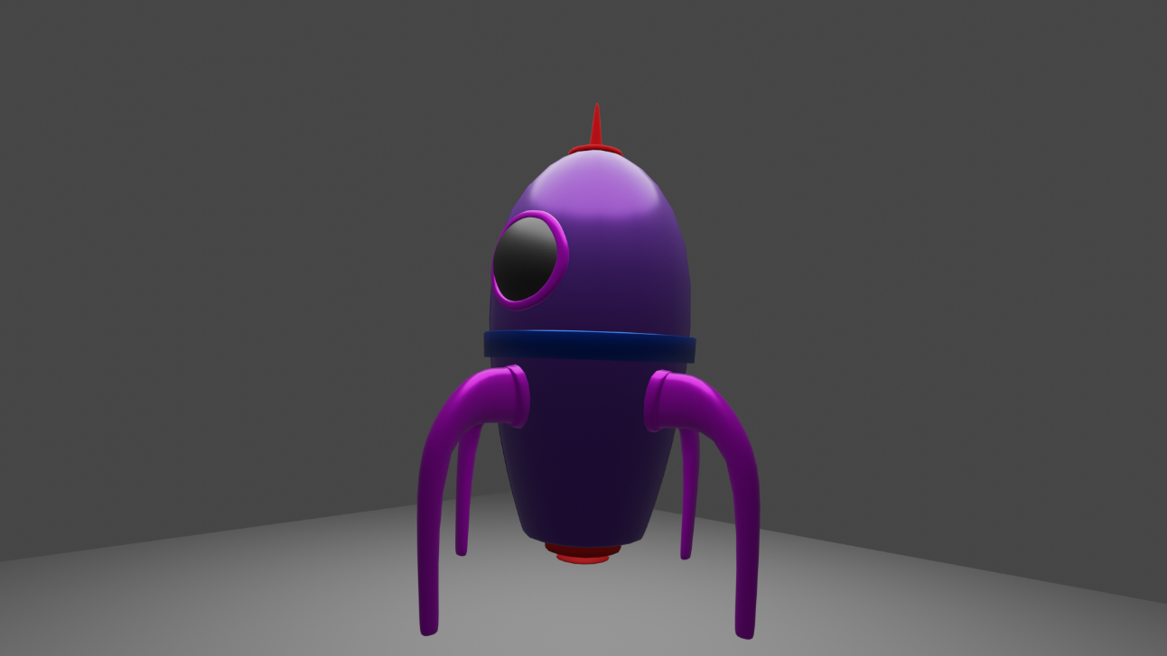

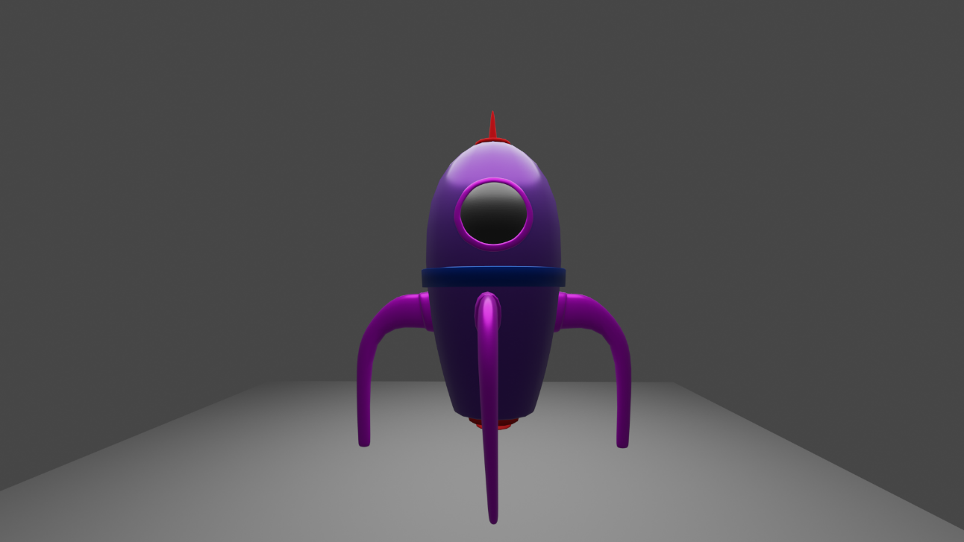

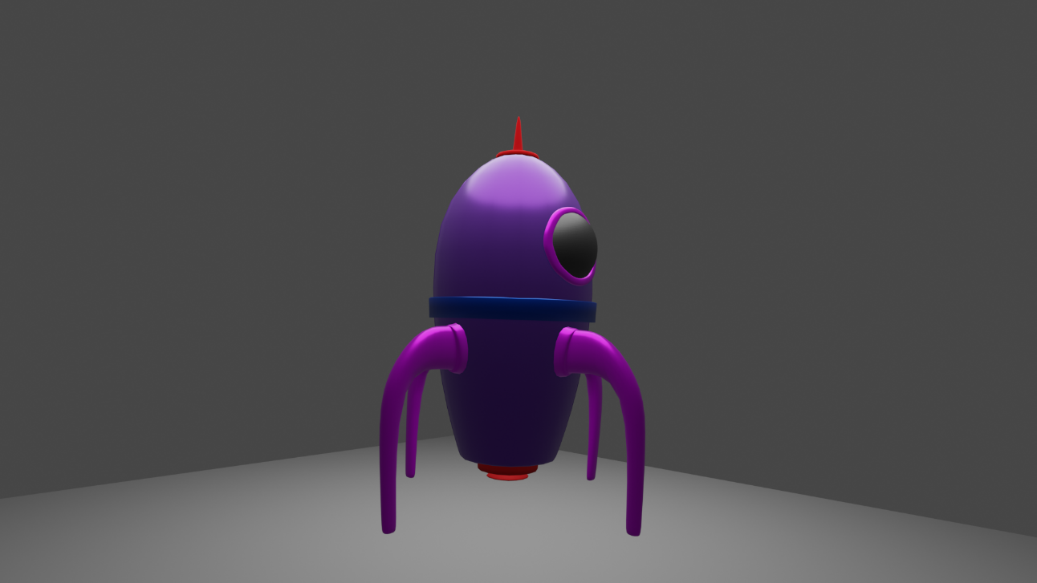

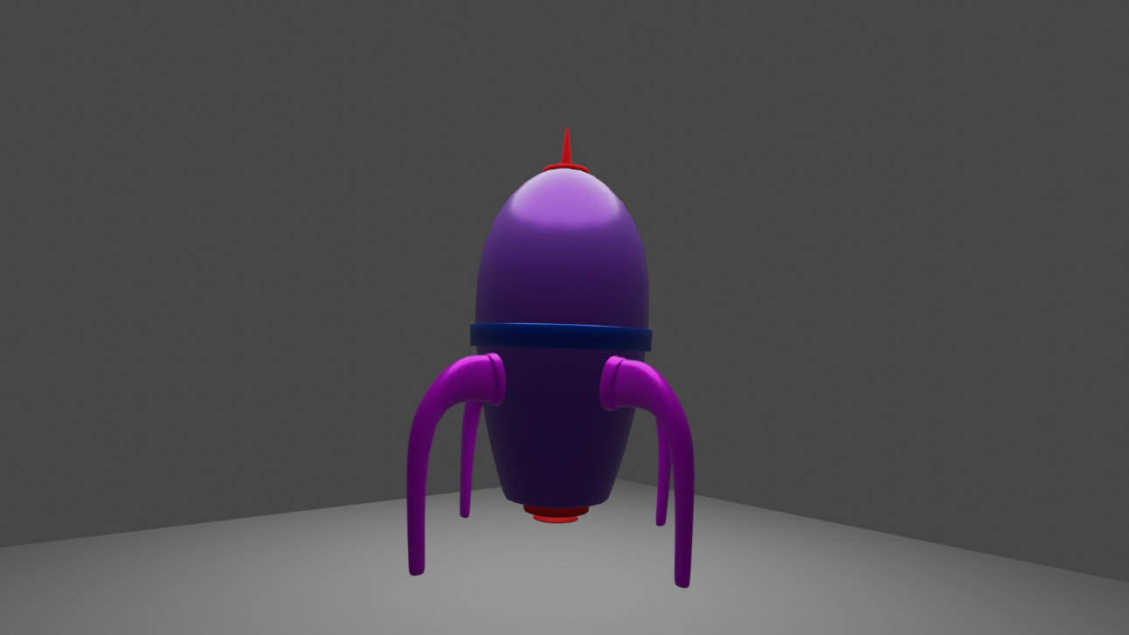

**Google Drive Link:** [**https://drive.google.com/drive/folders/18C0VtIAk-awUy3Axst3degZLR7YdXza2?usp=sharing**](https://drive.google.com/drive/folders/18C0VtIAk-awUy3Axst3degZLR7YdXza2?usp=sharing)